Software and Hardware Tools

1. Wireshark Image :
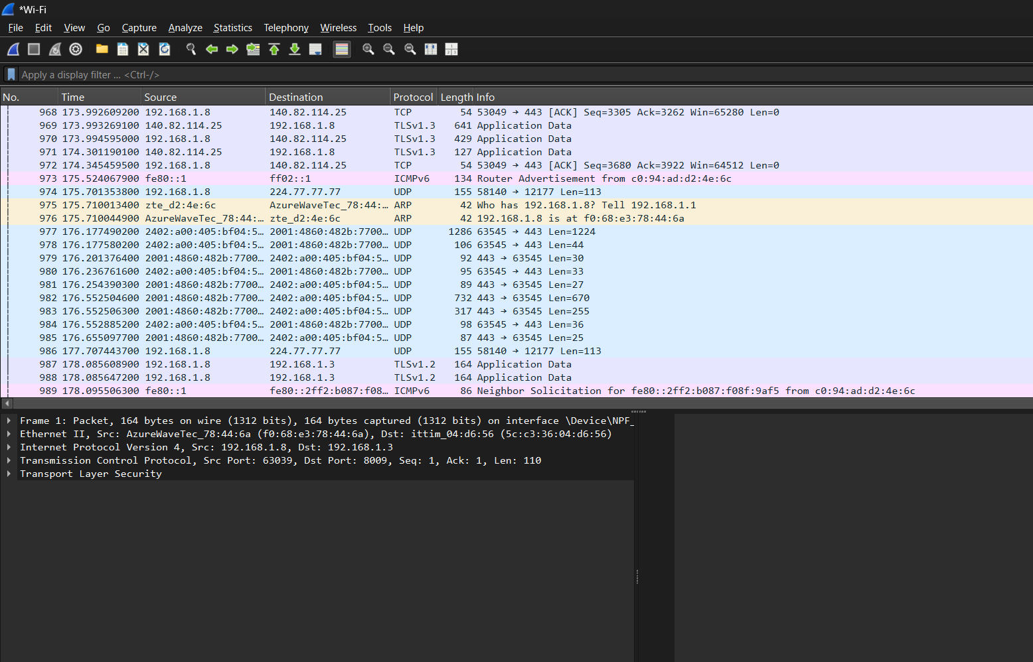

- QUIC / UDP: YouTube and Instagram use this protocol to load high-speed video and images quickly without buffering.
- TLS (or HTTPS): Encrypts your network data so your login credentials and personal activity remain secure.
- DNS: Translates human-readable domain names (like instagram.com) into computer-friendly IP addresses.

2. Using ping Command :
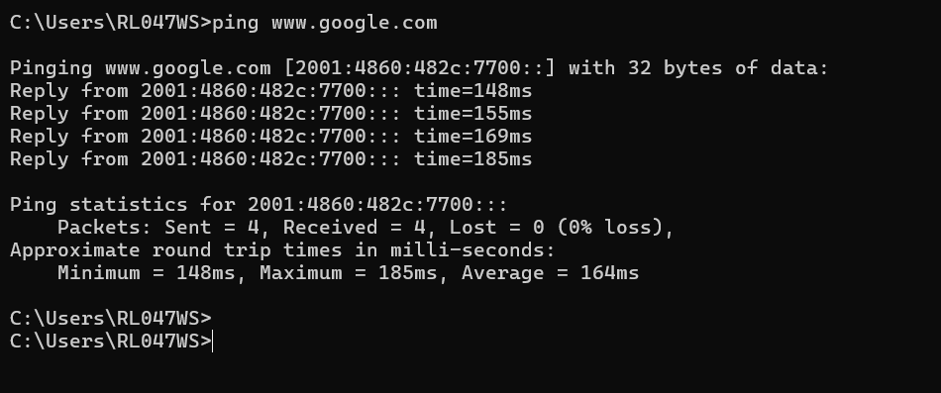

3. Task manager :

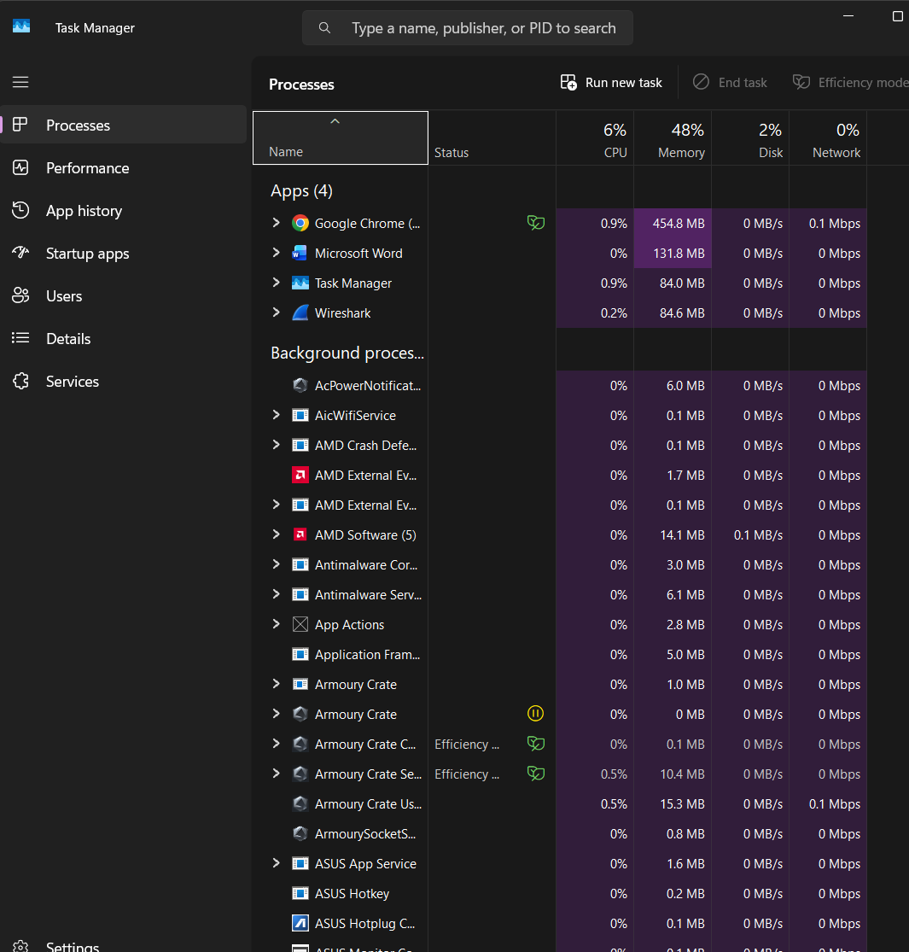
4. Advanced IP scanner :

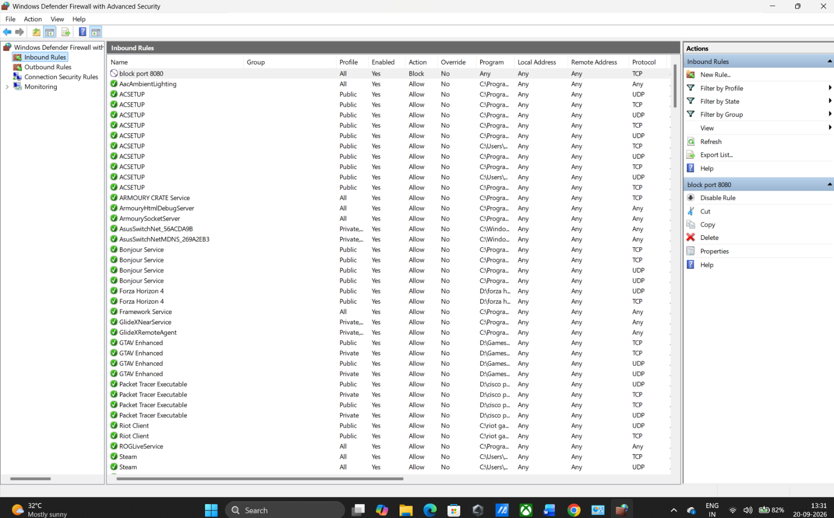
5. Essential Hardware Troubleshooting Tools :
1.Ethernet Cable Tester:Cable Verification.
When to use: Use this when an internet wall jack or Network cable is plugged in, but your computer still says "No Internet connection" (it checks if the wire inside is broken).
2.RJ45 Crimping Tool:Cable Repair.
When to use: Use this when you need to make a custom Ethernet cable or fix a broken plastic end-plug on an existing network cable.
3.Digital Multimeter:Power Supply Check.
When to use: Use this when a network router or switch will not turn on, and you need to test if the power adapter or outlet is supplying electricity correctly.

